What is the Diamond Problem?
When we inherit more than one base class in the same derived class and all these base classes also inherit another but same single class (super parent), multiple references of the super parent class become available to the derived class.
So, it becomes unclear to the derived class, which version of the super parent class it should refer to.
Consider the following program for instance:
#include <iostream>
using namespace std;

//super parent class
class A{
public:
void name(){
cout << "This is class A \n";
}
};

//base class I
class B: public A{};

//base class II
class C: public A{};

//derived class
class D: public B, public C{};

int main()
{
D d;
d.name();

return 0;
}
There is no syntactical error in the above program but still, if we try to compile then it returns the following compilation error:
Virtual Inheritance

This ambiguity often occurs in the case of multiple inheritances and is popularly known as the diamond problem in C++. To remove this ambiguity, we use “virtual inheritance” to inherit the super parent.
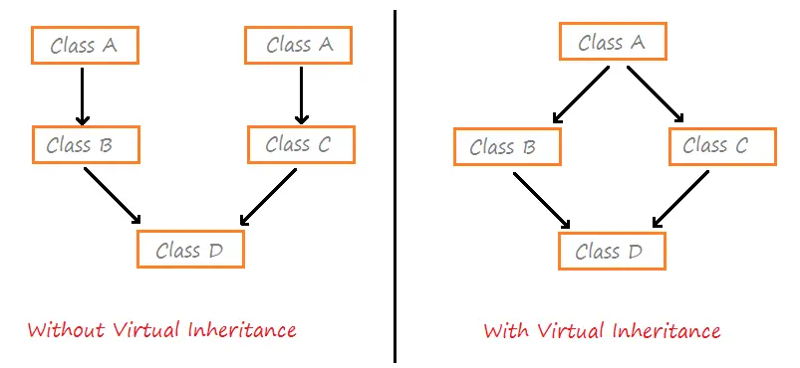
Solution
#include <iostream>
using namespace std;

//super parent class
class A{
public:
void name(){
cout << "This is class A \n";
}
};

//base class I
class B: virtual public A{};

//base class II
class C: virtual public A{};

//derived class
class D: public B, public C{};

int main()
{
D d;
d.name();

return 0;
}

Output:

This is class A

Public vs Protected in C++ with Examples
All the class members declared under public will be available to everyone. The data members and member functions declared public can be accessed by other classes too. The public members of a class can be accessed from anywhere in the program using the direct member access operator (.) with the object of that class.

// C++ program to demonstrate public access modifier

#include <iostream>
using namespace std;

// class definition
class Circle {
public:
double radius;

double compute_area()
{
return 3.14 * radius * radius;
}
};

// main function
int main()
{
Circle obj;

// accessing public data member outside class
obj.radius = 5.5;

cout << "Radius is: " << obj.radius << "\n";
cout << "Area is: " << obj.compute_area();
return 0;
}
Output:
Radius is: 5.5
Area is: 94.985
Protected
Protected access modifier is similar to that of private access modifiers, the difference is that the class member declared as Protected are inaccessible outside the class but they can be accessed by any subclass(derived class) of that class.
Example:
// C++ program to demonstrate
// protected access modifier
#include <bits/stdc++.h>
using namespace std;

// base class
class Parent {
// protected data members
protected:
int id_protected;
};

// sub class or derived class
class Child : public Parent {

public:
void setId(int id)
{
// Child class is able to access the inherited protected data members of base class

id_protected = id;
}
void displayId()
{
cout << "id_protected is: " << id_protected << endl;
}
};
// main function
int main()
{
Child obj1;
// member function of the derived class can access the protected data members of the base class
obj1.setId(81);
obj1.displayId();
return 0;
}
Public | Protected
All the class members declared under public will be available to everyone. | Protected access modifier is similar to that of private access modifiers.
The data members and member functions declared public can be accessed by other classes too. | The class member declared as Protected are inaccessible outside the class but they can be accessed by any subclass(derived class) of that class.

2. Private: The class members declared as private can be accessed only by the member functions inside the class. They are not allowed to be accessed directly by any object or function outside the class. Only the member functions or the friend functions are allowed to access the private data members of the class.
// C++ program to demonstrate private access modifier

#include<iostream>
using namespace std;

class Circle
{
// private data member
private:
double radius;

// public member function
public:
void compute_area(double r)
{ // member function can access private
// data member radius
radius = r;

double area = 3.14*radius*radius;

cout << "Radius is: " << radius << endl;
cout << "Area is: " << area;
}

};

// main function
int main()
{
// creating object of the class
Circle obj;

// trying to access private data member
// directly outside the class
obj.compute_area(1.5);

return 0;
}

//Friend Class to access private, protected and public members.
#include <iostream>
using namespace std;

// Forward declaration of the FriendClass
class FriendClass;

class Circle {
// Declare FriendClass as a friend class
friend class FriendClass;

private:
double radius;

public:
void compute_area(double r) {
radius = r;
double area = 3.14 * radius * radius;
cout << "Radius is: " << radius << endl;
cout << "Area is: " << area;
}
};

// Friend class that can access the private data member of Circle
class FriendClass {
public:
void accessPrivateData(Circle c, double r) {
c.radius = r; // Access the private data member radius
cout << "FriendClass accessing private data member (radius): " << c.radius << endl;
}
};

int main() {
Circle obj;
FriendClass friendObj;

// Access the private data member using the friend class
friendObj.accessPrivateData(obj, 1.5);

return 0;
}

// Friend Function
#include <iostream>
using namespace std;

class beta;
class alpha
{
private: int data;
public:alpha()// No argument constructor
{
data=3;
}
friend int frifunc(alpha, beta);//friend func
};
class beta{
private:
int data;
public:
beta()
{
data=7;

}
friend int frifunc(alpha,beta);
};
int frifunc(alpha a, beta b)//friend fn definition
{
return (a.data+b.data);
}
int main()

{
alpha aa;
beta bb;
cout<<frifunc(aa,bb)<<endl;
return 0;
}
Output:
10

// Friend Class
#include <iostream>
using namespace std;

class alpha
{
private:
int data1;

public:
alpha()
{
data1 = 99;
}
friend class beta;
};

class beta
{ // It can access private alpha data

public:
void func1(alpha a)
{
cout << "Data1=" << a.data1;
}
void func2(alpha a)
{
cout << "Data1=" << a.data1;
}
};

int main()
{
alpha a;
beta b;
b.func1(a); // Call func1 on the instance of beta
b.func2(a); // Call func2 on the instance of beta
cout<<endl;
return 0;
}
Output:
Data1=99
Data1=99

Function Overriding
Function overriding in C++ is termed as the redefinition of base class function in its derived class with the same signature i.e. return type and parameters. It falls under the category of Runtime Polymorphism.

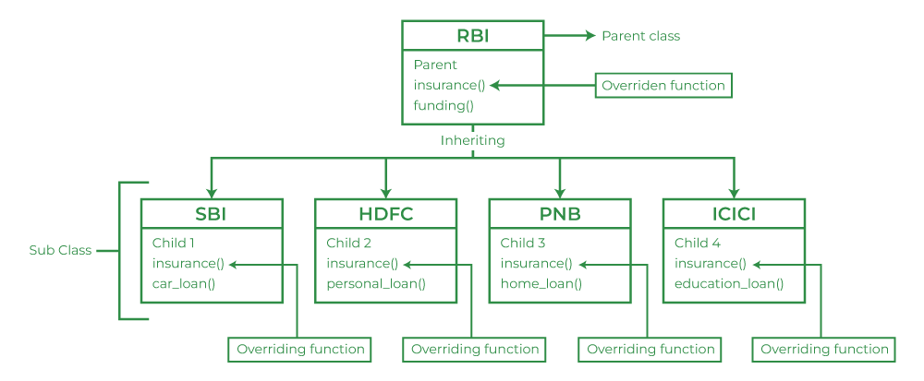

// C++ program to demonstrate function overriding

#include <iostream>
using namespace std;

class Parent {
public:
void abc_Print()
{
cout << "Base Function" << endl;
}
};

class Child : public Parent {
public:
void abc_Print()
{
cout << "Derived Function" << endl;
}
};

int main()
{
Child Child_Derived;
Child_Derived.abc_Print();
return 0;
}

Variations in Function Overriding

1. Call Overridden Function From Derived Class

// C++ program to demonstrate function overriding
// by calling the overridden function
// of a member function from the child class

#include <iostream>
using namespace std;

class Parent {
public:
void abc_Print()
{
cout << "Base Function" << endl;
}
};

class Child : public Parent {
public:
void abc_Print()
{
cout << "Derived Function" << endl;

// call of overridden function
Parent::abc_Print();
}
};

int main()
{
Child Child_Derived;
Child_Derived.abc_Print();
return 0;
}
Output

Derived Function
Base Function

// C++ program to access overridden function using pointer of Base type that points to an object of

Derived class
#include <iostream>
using namespace std;

class Parent {
public:
void abc()
{
cout << "Base Function" << endl;
}
};

class Child : public Parent {
public:
void abc()
{
cout << "Derived Function" << endl;
}
};

int main()
{
Child Child_Derived;

// pointer of Parent type that points to derived1
Parent* ptr = &Child_Derived;

// call function of Base class using ptr
ptr->abc();
return 0;
}
output: Base Function

